**Day 1- 201939818- Gangadhar Pedagopi**

**1. What is SDLC ?**

It is refers as the application life cycle.

Process used by software industry to design, develop, and test software.

It includes

Planning

Analysis

Design

Coding

Testing

Deployment & Maintenance

**2.Why is SDLC ?**

Helps developers to create secure and valuable software.

Teams can better manage resources, control costs, minimize risks, and ensure the final product meets user requirements.

**3.Stages in SDLC ?**

Planning - the initial stage where project goals, scope, and requirements are defined, and a project plan is created,

Analysis - the development team dives deep into understanding the client's needs and identifying potential problems to ensure the final product meets expectations

Design - Involves creating the software's architecture and layout(blueprint), ensuring it meets the defined requirements

Coding – translate design into coding

Testing - checking the software for defects and issues. It ensures the software functions correctly

Deployment - releasing the software to end-users in a live environment,

Maintenance - focuses on ongoing support and improvements after deployment

**4.SDLC Models**

**Agile Model :**

Agile projects are broken down into smaller iterations or sprints

It prioritizes collaboration, adaptability, and rapid delivery

It involves regularly collecting, processing, and acting on feedback from various sources, including customers.

**Advantages**- Higher Customer Satisfaction, Faster Delivery, Flexibility and Adaptability

**Disadvantages**- Difficulty in Planning, Difficult to Measure Progress

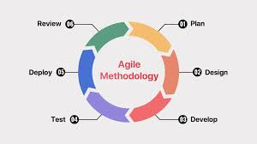

**Waterfall Model :**

It is a sequential software development approach where each phase must be completed before the next can begin, with no backtracking.

Phases include requirements, design, implementation, Testing,Deployment and maintenance.

**Advantages** - Easy to Estimate Timelines and Budgets, Suitable for Smaller Projects

**Disadvantages** - Not Suitable for Complex Projects, Can be Time-Consuming, Delays in Testing

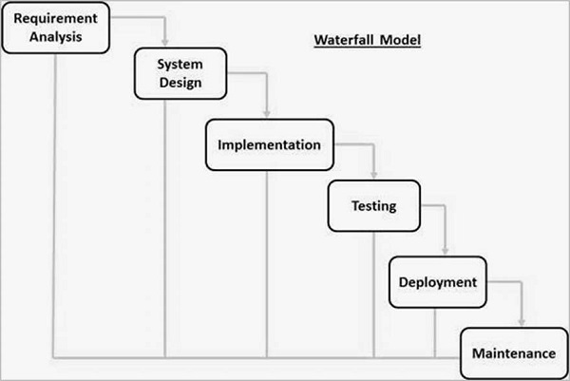

**V-Model :**

It is also called Verification and Validation Model.

V-Model is widely used in the Software Development Process, and it is considered a disciplined model.

Each development stage has an associated testing phase

**Advantages** - It enables project management to track progress accurately.

**Disadvantages**- V-Model can be time-consuming, as it requires a lot of documentation and testing

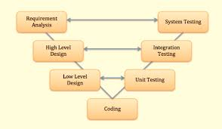

**Iterative Model :**

It is a way of breaking down the software development lifecycle (SDLC) of a large application into smaller parts.

as it represents how repetition leads to perfection.

**Advantages** - It is easily adaptable to the ever changing needs of the project as well as the client.

**Disadavantages**- It is not suitable for smaller projects.

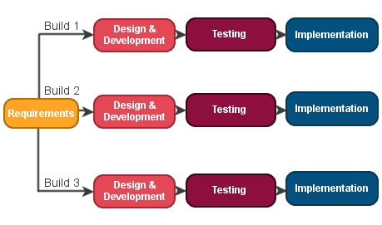

**5.Applications**

Agile Model- it well-suited for projects with evolving requirements.

Waterfall Model- it suitable for projects with clear, stable requirements and a predictable outcome

V Model – It is used for small projects where project requirements are clear and projects requires extensive testing.

Iterative Model- It is suitable for the projects, when the product needs to be delivered in stages.

**Scrum**

It is a framework used in software management that helps teams to collaborate and manage work and solve problems.   
In simple words scrum is used to break down complex projects into smaller parts (Sprints) and to manage it accordingly and it helps in adaptation for continuous improvement and changes.

**Sprint**

Sprint is a short time period where a team works to complete a specific goal or work

**Do’s :**

Prioritize and Clarify User Stories

Focus on Quality

Communicate Clearly

**Don’ts :**

Don't Rush Planning

Ignoring Quality or Technical Debt

Not to Focus only on Features

**Backlog**

a backlog is a prioritized list of work items that need to be completed.

**Stories**

Stories are individual items within the backlog , describing a specific feature or functionality.

**Scrum Artifacts:**

**Product Backlog** - Product Backlog is a prioritized list of tasks and requirements that the development team uses to deliver a product.

Ex : A list of features to be added to a mobile app, prioritized by user needs.

**Sprint Backlog** - A fixed time period for completing a defined amount of work.

Ex : A list of tasks to implement a specific feature in a mobile app during a Sprint

**Increment** - The Increment is the result of a Sprint, containing all the completed Product Backlog items are Done

Ex : mobile app with the completed features from the Sprint.

**Ports :**

A port is a numerical address that identifies a specific process or service on a network-connected device.

Ports act as communication endpoints, facilitating data transfer between devices and applications.

Ports are identified by a unique number, typically within the range of 0 to 65535.

**Protocol :**

A protocol is a set of rules for formatting and processing data. Network protocols acts as a common language for device to communicate.

**Network Types**

1. LAN (Local Area Network)
2. WAN (Wide Area Network)
3. MAN (Metropolitan Area Network)
4. WLAN (Wireless Local Area Network)
5. VPN (Virtual Private Network)
6. VLAN (Virtual Local Area Network)

**Types of Servers :**

Web servers, Database servers, Mail servers,and Application servers

**Web servers :** These servers host websites and web applications, delivering web pages to users' browsers.

Example : Microsoft IIS, Apache

**Database servers :** Dedicated to storing and managing data, often using database management systems (DBMS)

Example : MySQL, Oracle, SQL Server, MongoDB

**Mail servers :** Handle the sending, receiving, and storing of email messages.

Example :

**Application servers :** Host and manage the execution of software applications, often acting as a bridge between users and back-end systems

Example : Tomcat, JBoss, WebSphere

**DNS (Domain Name System) :**

The Domain Name System (DNS) acts as the internet's phonebook, translating human-readable domain names (like google.com) into the IP addresses that computers use to communicate.

**VPN (Virtual Private Network) :**

A VPN, or Virtual Private Network, is a technology that creates a secure, encrypted connection between our device and the internet, allowing you to access the internet privately and securely.

**Remote Access VPN:**

These VPNs are designed for individual users to connect to a private network from a remote location, such as a home or a business's satellite office.

**Site-to-Site VPN:**

This type of VPN creates secure connections between different physical locations, like separate offices or branch locations of a company.

**Types of VPN**

**Network Topology :**

Network topology describes the physical and logical layout of a network, outlining how devices and connections are arranged. It shows how data flows between devices and impacts performance, security, and scalability. Understanding network topology is crucial for designing, managing, and troubleshooting computer networks

**Types of Topology :**

**Bus Topology:**

All devices are connected to a single shared cable.

Simple and cost-effective, but can be slow and prone to collisions if many devices try to transmit at once.

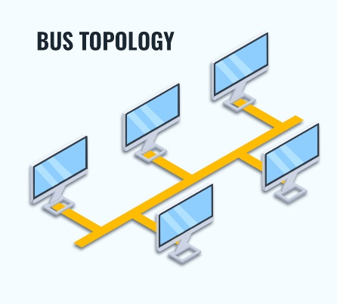

**Star Topology:**

Devices are connected to a central hub or switch, making troubleshooting easier. If the central hub fails, the entire network can be affected.

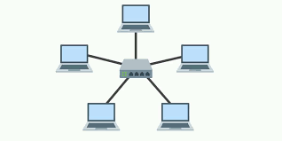

**Ring Topology:**

Devices are connected in a closed loop, with data flowing in one or both directions. It can be cost-effective, but troubleshooting can be more complex.

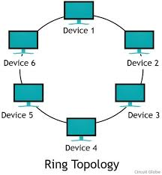

**Mesh Topology:**

Each device is directly connected to every other device, providing redundancy and fault tolerance. However, it can be expensive to set up and manage.

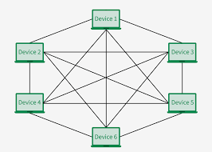

**Hybrid Topology:**

Combines two or more of the other topologies.

Provides flexibility and scalability, but can be complex to manage and troubleshoot.

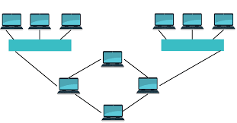

**Point-to-Point Topology:**

A direct link between two nodes.

Simple and cost-effective, but not scalable

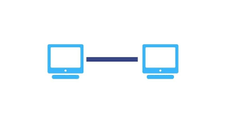

**What is OSI Model ? Describe the 7 layers with description**

**OSI Model : (**Open Systems Interconnection**)**

The OSI model is a conceptual framework that divides network communications into seven distinct layers, each responsible for specific functions.

It provides a standardized way to understand and troubleshoot network problems.

**Application Layer**: This is the top layer, where applications interact with the network.

**Presentation Layer**: Handles data formatting, encryption, and compression.

**Session Layer**: Establishes, manages, and terminates connections between applications.

**Transport Layer**: Provides reliable and ordered data delivery between endpoints.

**Network Layer**: Handles routing data packets across the network.

**Data Link Layer**: Handles the physical transmission of data frames between devices on a single network.

**Physical Layer**: Deals with the physical transmission of bits (0s and 1s) over the network media.